Using DekDrain Eezee Outlet Connector (DCD-EZ-OC)
Usage:
48mm Eezee Outlet to 100mm bore underground drainage pipe multi material. To be used with the DCD-EZ-98-SOEC (Socket End Cap for Eezee channel Black c/w 50mm Outlet Option) and DCD-EZ-98-SPEC (Spigot End Cap for B125 channel Black c/w 50mm Outlet Option).
The DekDrain Outlet connector is made up of two components:
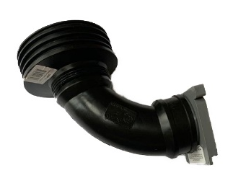
- DECE-L-48 - 90-degree Value-Flex Elbow
- UWA - universal 100mm drain connector

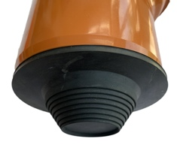
Use and assembly instructions:
Prior to assembly, you can use the UWA as a stopper on your drain to protect your underground drainage pipe from debris falling into it.

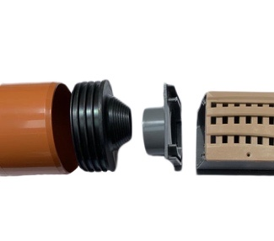
Horizontal 2-4-inch Connection
Cut a 50mm hole in the UWA cone with a pair of scissors or a trimming knife (scissors will be safer). Push the UWA over the outlet end cap. The UWA is eccentric/offset, and by simple rotation the 100 mm pipe can be positioned just below the grating cover level.

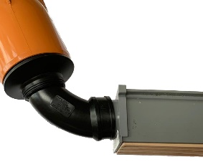
0-90-degree 2-4inch Connection
Cut a 50mm hole in the UWA cone with a pair of scissors or a trimming knife (scissors will be safer). Remove one hose clamp from the 90-degree elbow (the band is no longer needed for this adaptation). Apply a small amount of DEKS lubricant to the components so they will slide together easily.
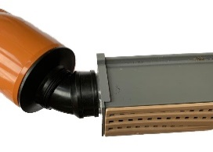
Push the socket of the 90-degree elbow into the UWA connector, using the end where the clamp band was previously sitting. You may need to compress or fold the 90-degree elbow to enable it to pass through the UWA.
Place the elbow socket over the outlet end cap spigot and tighten the clamp band (do not overtighten). To adjust the direction, release the band and adjust as needed.
Connect the UWA end into the 4-inch underground drainage pipe – this is a friction fit.
By moving the elbow through the UWA, you will be able to achieve the desired angle between 10 and 90-degrees. With the offset in the UWA and adjustable movement, you can achieve an almost infinite number of directions. By rotating the connector on the Eezee outlet end cap when connected, the direction of the outlet can be move between vertical and horizontal.
Tip:
In the unlikely event that you cannot meet and connect to your underground drain, use underground 100mm bends to meet the connector as easily as you can on site. As the connector locates on the inner wall of 100mm drainage, you can cut the 100mm drainpipe almost anywhere to achieve this.

90-degree 2-2-inch Connection
For this connect, disregard the UWA. Connect one end of the 2-inch, 90-degree elbow to the Eezee outlet end cap and the other end of the 2-inch pipe and tighten the end bands accordingly.

Important Information and recommendations:
Under no circumstances should you try to overstretch or kink the flexible elbow, as this will create a blockage. If aggressive compaction is required around the assembly, ensure the elbow is embedded in mortar/concrete to avoid inward collapse and a blockage point.

*images are for illustrative purposes only and may not accurately depict your installation type.
Website: www.deks.co.uk/eezee

